**Bharathwaj.M**

**RA2011026020065**

**CSE-AIML- ‘A’ Section**

**Object Oriented Design and Programming(18CSC202J)**

**1)AIM:**

Inventory Management System Class Diagram describe the structure of an Inventory Management System classes, their attributes, the relationships among objects. The main classes of the inventory management system are inventory, Customer, Purchasing, Stock, Payment and Supplier.

**2)Description:**

**Classes of Inventory Management System Class Diagram:**

* Inventory Class: Manage all the operations of inventory.
* Customer Class: Manage all the operations of customer.
* Purchasing Class: Manage all the operations of purchasing.
* Stock Class: Manage all the operations of stock.
* Payment Class: Manage all the operations of Payment.
* Supplier Class: Manage all the operations of Supplier.

**Classes and their attributes of Inventory Management System Class Diagram:**

* Inventory Attributes: inventory_id, inventory_items, inventory_number, inventory_type, inventory_description.
* Customer Attributes: customer_id, customer_name, customer_mobile, customer_email.
* Purchasing Attributes: purchase_id, purchase_customer_id, purchse_amout, purchase_type, purchase_total, purchase_receipt, purchase_bill, purchase_description.
* Stock Attributes: stock_id, stock_items, stock_number, stock_type, stock_description.
* Payment Attributes: payment_id, payment_customer_id,payment_date, payment_amount, payment_description.
* Supplier Attributes: supplier_id,supplier_name,supplier_mobile,supplier_username,supplier_password,supplier_address.

**Classes and their methods of inventory Management System Class Diagram:**

* Inventory Methods: addInventory(),editInventory(),deleteinventory(),updateInbentory(),

saveinventory(),searchInventory().

* Customer Methods: addCustomer(),editCustomer(),deleteCustomer(),updateCustomer(),

saveCustomer(),searchCustomer().

* Purchasing Methods: addPurchasing(),editPurchasing(),deletePurchasing(),updatePurchasing(),savePurchasing(),searchPurchasing().
* Stock Methods: addStock(),editStock(),deleteStock(),updateStock(),saveStock(),searchStock().
* Payment Methods: addPayment(),editPayment(),deletePayment(),updatePayment(),savePayment(),searchPayment().
* Supplier Methods: addSupplier(),editSupplier(),deleteSupplier(),updateSupplier(),saveSupplier(),searchSupplier().

**3)Diagram:**

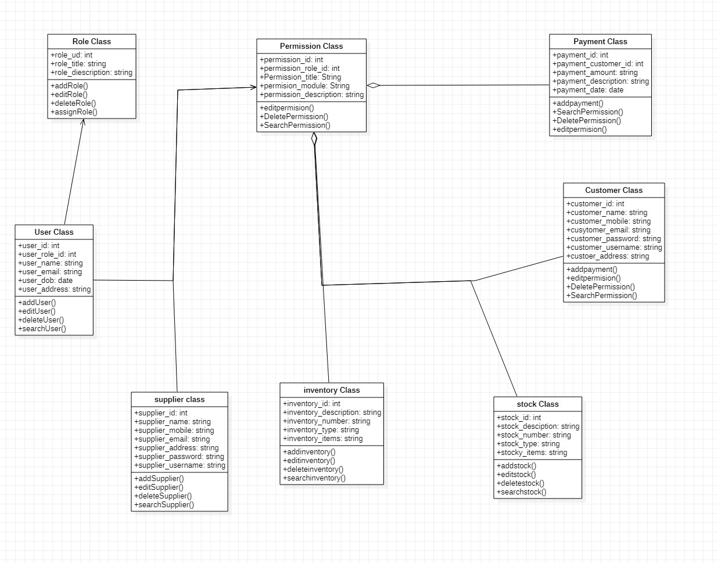

**4)Result:**

Hence, we described the Inventory management system class diagram and the structure of the system(above).